Design Phase
1. Overview
The Design phase focused on developing a scalable, modular, and efficient architecture for an AI-powered illegal dumping detection system. The system was designed to operate in real time, process CCTV video streams, and generate actionable insights through an integrated dashboard.
Key design objectives included:
- achieving real-time performance (15–30 FPS)
- maintaining high detection accuracy (≥80%)
- ensuring scalability and modularity
- addressing hardware and data constraints
2. Design Rationale
The system adopts a pipeline-based modular architecture to optimise both performance and accuracy. Instead of applying deep learning models to every frame, the system uses a staged approach:
- Motion detection filters irrelevant frames
- Object tracking monitors behaviour over time
- Classification is applied only when necessary
This design reduces computational overhead and ensures real-time performance. A modular architecture was chosen to allow independent development, testing, and scaling of components such as AI processing, backend services, and visualisation layers.

3. System Architecture Design
The system adopts a multi-layered architecture, separating concerns across different components to improve maintainability and scalability.
AI Processing Layer
This layer handles video analysis and consists of:
- motion detection
- object tracking
- classification (MobileNetV3)
This staged approach enables the system to first detect movement, then track objects, and finally classify them, improving detection reliability.
Event Processing Layer
Once an object is classified as waste, an event is generated containing:
- timestamp
- confidence score
- object type
This structured representation ensures consistent data handling across the system.
Backend Layer
The backend (Flask-based) manages:
- API communication (JSON)
- event processing and streaming
- integration between system components
Data Storage Layer
A database is used to store:
- detected events
- logs
This enables historical analysis and system monitoring.
Presenation Layer
A Flask-based web dashboard provides:
• real-time alerts for detected events
• data visualisation including charts and trends
• GIS-based mapping for spatial analysis
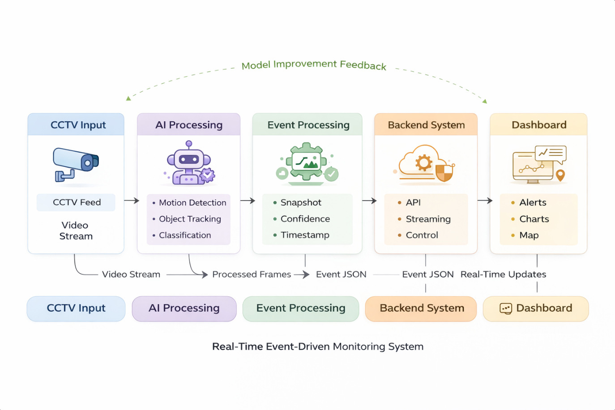
Figure 1 System Architecture Diagram

4. Data Flow and System Behaviour
The system operates as a continuous real-time pipeline, as illustrated in the control and data flow diagrams.
Data Flow:
- CCTV cameras provide video frames
- Frames are processed through the AI pipeline
- Detected waste events are converted into structured data
- Data is sent to the backend via API
- Events are stored in the database
- The dashboard retrieves and displays data
Control Logic:
- The system continuously processes frames in a loop
- Detection is triggered only when motion is detected
- Objects must remain stationary before classification
- Events are generated only when waste is confirmed
This design reduces false positives and improves efficiency.
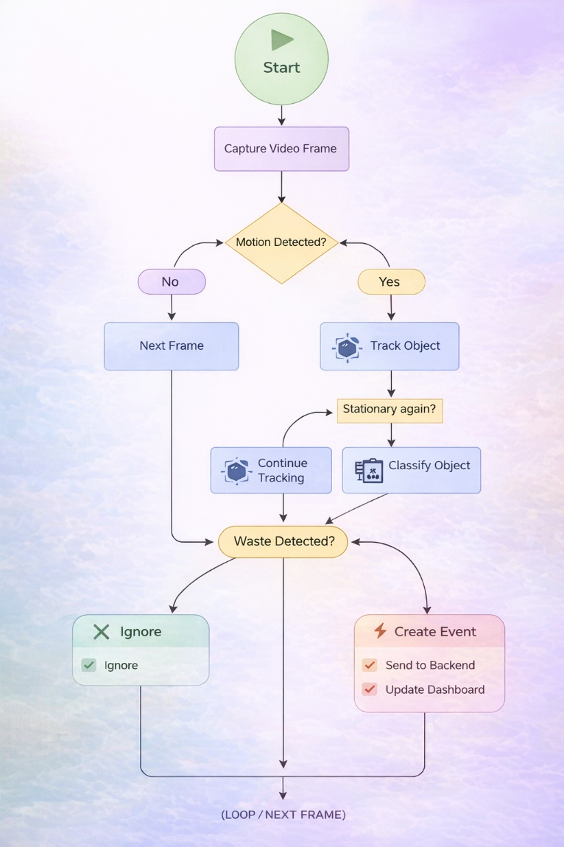
Figure 2 Control flow Diagram
The control flow diagram shows how the system processes video frames to detect illegal dumping. Each frame is analysed for motion, and if no motion is detected, the system skips processing to improve efficiency. When motion is detected, objects are tracked and monitored. If an object becomes stationary, it is classified using a deep learning model. If waste is detected, an event is created and sent to the backend, which updates the dashboard. Otherwise, the object is ignored. The system then continues processing the next frame in a continuous loop.

System Intent:

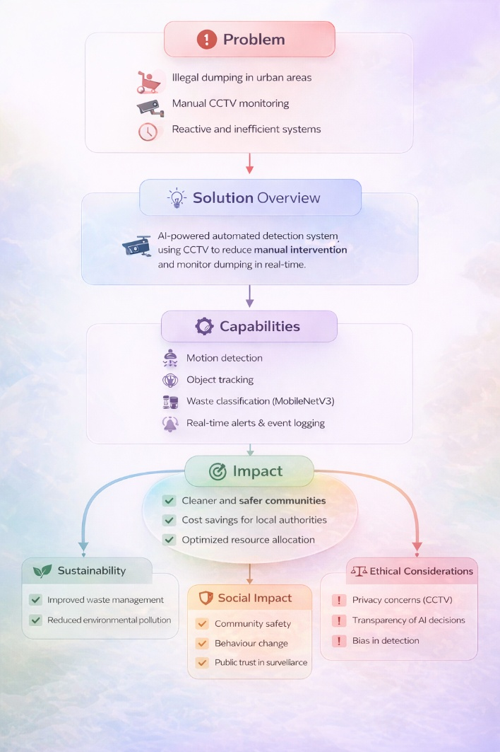
Figure 3 System Intent Diagram
The intent diagram outlines the purpose and impact of the system. It addresses key problems such as illegal dumping and inefficient manual monitoring by providing an AI-powered, real-time detection solution. The system’s capabilities, including motion detection, tracking, and classification, enable automated alerts and improved monitoring. These lead to outcomes such as increased efficiency, faster response times, and better detection accuracy. The diagram also highlights broader impacts, including sustainability, social benefits, and ethical considerations such as privacy and transparency.

5. Model Design and Selection
A Convolutional Neural Network (CNN) was used for classification, specifically MobileNetV3.
Justification:
- lightweight architecture suitable for real-time systems
- lower computational requirements compared to ResNet/EfficientNet
- faster inference speed
Trade-Off:
- slightly lower accuracy compared to deeper models
- significantly improved performance and efficiency
To address data limitations, the model was enhanced using:
- transfer learning
- data augmentation

6. Technology Stack Justification
Category | Tool / Technology | Technique Used | Algorithm / Model | Purpose in System
Computer Vision | OpenCV | Frame capture, image processing | — | Captures and processes CCTV video streams
Motion Detection | OpenCV | Background subtraction, thresholding, morphological filtering | MOG2 Background Subtractor | Detects moving objects within video frames
Object Detection | OpenCV | Contour detection, bounding box extraction | Connected Components Analysis | Identifies object regions in the scene
Object Tracking | NumPy, OpenCV | Centroid tracking, distance-based matching | Custom Tracking Algorithm | Tracks objects across frames over time
Behaviour Analysis | Python (custom logic) | Temporal analysis, stationary object detection | Rule-based Event Detection | Identifies potential dumping events
Deep Learning | PyTorch, Torchvision | Transfer learning, feature extraction | MobileNetV3 CNN | Classifies objects as waste or non-waste
Inference | PyTorch | Softmax classification, thresholding | Neural Network Inference | Generates prediction with confidence score
Dataset Processing | OpenCV, NumPy, YAML | Cropping, dataset transformation, data preprocessing | YOLO-to-Binary Conversion | Converts YOLO dataset into classification format
Backend System | Flask | REST API development, event streaming | — | Manages system communication and data flow
Data Streaming | Python (queue, threading) | Asynchronous processing | Producer–Consumer Model | Enables real-time event handling
Data Storage | JSON | Structured logging | — | Stores detected events and metadata
Data Analysis | Pandas | Data aggregation, filtering, time-series analysis | — | Processes data for insights and trends
Visualisation | Streamlit | Interactive dashboards, charts, UI rendering | — | Displays alerts and analytics to users

These technologies were selected to balance performance, simplicity, and scalability.

7. Design Decisions and Trade-Offs
Several key design decisions were made:
Accuracy vs Performance
- High-complexity models were rejected due to latency
- MobileNetV3 selected to ensure real-time processing
Real-Time Processing vs System Complexity
- A multi-stage pipeline was used instead of a single model
- improves reliability but increases system complexity
Local vs Cloud Processing
- Local processing used for prototype
- cloud deployment considered for scalability
Simplicity vs Scalability
- modular architecture allows future expansion

8. Dataset and Data Handling
The system uses CCTV video data and structured datasets for training.
Data Processing:
- Frame extraction from video
- Image resizing and normalisation
- Noise reduction
Challenges:
- Limited labelled data
- Class imbalance
- Environmental variations (lighting, occlusion)
Solutions:
- Data augmentation
- Transfer learning
- Dataset transformation (YOLO to classification format)

9. Design Decisions and Trade-Offs
Accuracy vs Performance
- Lightweight model chosen to meet real-time constraints
Real-Time vs Complexity
- Multi-stage pipeline improves reliability but increases complexity
Local vs Cloud Processing
- Local processing used for prototype
- Cloud considered for scalability
Simplicity vs Scalability
- Modular design enables future expansion
10. Deployment Architecture
The system is designed for both local and scalable deployment:
Current (Prototype):
- CCTV feed processed locally
- AI pipeline runs on local machine
- Flask backend handles communication
- Dashboard accessed via web interface
Future (Scalable):
- Cloud-based backend deployment
- Multiple camera integration
- Distributed processing
This ensures the system can evolve into a real-world solution.

11. Performance Considerations
The system was optimised for:
- Low latency (<200 ms)
- Real-time processing (15–30 FPS)
- Efficient resource usage
Performance is improved by filtering frames before classification and reducing unnecessary computations.

12. Evaluation and Validation Strategy
System performance is evaluated using:
Metrics:
- Accuracy
- Precision and Recall
- False Positive Rate
- Confusion Matrix
Testing:
- Real-time CCTV simulation
- Different environmental conditions (day/night)
- Multiple object scenarios
Validation:
- Integration testing across components
- End-to-end system testing
- User/stakeholder feedback

13. Constraints and Limitations
The design was influenced by several constraints:
🔹 Hardware Constraints
- limited GPU availability
→ required lightweight models
🔹 Data Limitations
- limited labelled dataset
→ addressed using augmentation and transfer learning
🔹 Real-Time Requirements
- strict latency constraints
→ optimisation of processing pipeline

14. Ethical and Regulatory Considerations
Ethical principles were incorporated into the system design:
- Privacy by design: no facial recognition used
- Data minimisation: only relevant event data stored
- Transparency: event logging enables traceability
The system was designed to align with:
- GDPR
- data protection principles

15. Performance Requirements
The system was designed to meet the following targets:
- Accuracy: ≥ 80%
- Processing speed: 15–30 FPS
- Latency: < 200 ms
These requirements ensure practical usability in real-world environments.

16. Design Validation Strategy
To validate the design, the following approaches were used:
- testing across multiple environmental conditions
- evaluation of model accuracy and performance
- integration testing of system components
- stakeholder feedback on usability

17. Scalability and Integration
The modular architecture allows:
- Integration of multiple CCTV streams
- Expansion of backend services
- Future addition of advanced AI models

17. Future Improvements
- Use of more advanced detection models (e.g., YOLO)
- Edge AI deployment for faster processing
- Improved dataset diversity
- Enhanced real-time analytics

18. Summary
The Design phase demonstrates:
- a modular and scalable system architecture
- strong technical justification and trade-off analysis
- effective handling of constraints and real-time requirements
- integration of ethical and regulatory considerations
Overall, the design provides a robust foundation for a commercially viable, real-time AI monitoring system.

